# **SENTRY ALERT – Smart Detection and Alert System For Injured or Fallen Soldiers in Combat**

1. **Introduction**

Sentry Alert is a smart detection and alert system designed to protect soldiers in combat. A helmet-mounted unit monitors movement and vitals, and if it detects a fall, injury, or prolonged inactivity, it automatically sends an alert with the soldier’s ID and GPS location to a receiving unit. A manual panic switch ensures security in critical situations. This system enables faster rescue, better safety, and improved mission effectiveness.

1. **Project Description**

We aim to build a dual-unit system consisting of a Sending Unit (attached to the soldier’s helmet) and a Receiving Unit (carried by another soldier or stationed at the base). The Sending Unit continuously monitors the soldier’s movement and vitals. If it detects a dangerous fall, no motion for a certain time, or signs of injury or unconsciousness through vitals, it automatically sends an emergency alert using a GSM-based communication system. This alert contains the soldier’s unique ID and GPS coordinates. On the other side, the Receiving Unit receives this alert and displays all the necessary information — including who is down and where — along with visual/audible indicators. This will help teammates quickly locate and assist the injured comrade, especially in rough terrain or high-stress scenarios like covert missions. The system also includes a panic kill switch, which the soldier can press manually in the worst-case scenario (such as being captured). Once triggered, it will immediately erase all critical data and disable the transmitter to prevent enemy tracking.

## **System Workflow**

1. **Sending Unit (Helmet-mounted)**
2. Continuously monitors body movement using an accelerometer and gyroscope (IMU).
3. Simultaneously checks vital signs like pulse and blood oxygen level using a biometric
4. Retrieves GPS coordinates in real-time.
5. If it detects a fall + abnormal vitals (or prolonged inactivity), it:

(i). Triggers an emergency protocol.

(ii). Sends a message via GSM to the Receiving Unit.

1. **Receiving Unit (Portable or Base Station)**
   1. Waits passively for incoming alerts.
   2. When an alert is received via GSM, it:

(i). Displays the soldier’s ID and location.

(ii). Activates a buzzer and LED for immediate attention.

1. **Manual Panic Kill Switch:**

Instantly wipes the memory and shuts down communication when pressed, protecting data and preventing signal tracking.

## **Final Component List and Budget Breakdown:**

|  |  |  |  |  |  |  |
| --- | --- | --- | --- | --- | --- | --- |
| No. | Component | Model | Unit Used | Unit Cost | Quantity | Total Cost |
| 1 | Microcontroller | ESP32 Dev Board | Sender & Receiver | 500 | 2 | 1000 |
| 2 | Motion Sensor | MPU6050 (GY-521) | Sender | 220 | 1 | 220 |
| 3 | Vital Sensor | MAX30102 | Sender | 200 | 1 | 200 |
| 4 | GPS Module | Neo-6M GPS | Sender | 500 | 1 | 500 |
| 5 | GSM Module | SIM800L GSM | Both | 370 | 2 | 740 |
| 6 | Kill/Panic Switch | Panic Tactile Switch | Sender | 5 | 2 | 10 |
| 7 | Alert Output | LED | Both | 5 | 1 | 5 |
| 8 | Alert Output | Buzzer | Both | 15 | 2 | 30 |
| 9 | Power Module | TP4056 Charger | Both | 30 | 2 | 60 |
| 10 | Charging Module | 18650 Li-ion Battery | Both | 180 | 2 | 360 |
| 11 | Display | 0.96” OLED | Receiver | 300 | 1 | 300 |
| 12 | Insulation Material | Heat Shrink Tube | Both | 7 | 5 | 35 |
| 13 | Prototyping Board | Breadboard | Both | 145 | 2 | 290 |
| 14 | SMS Module | 2 Micro Sim | Both | 500 | 2 | 1000 |
| 15 | Capacitor | 470 µF | Both | 5 | 2 | 10 |
| 16 | Resistor | 1k Ω, 2k Ω | Both | 5 | 3 | 15 |
| 17 | SIM Card |  | Both | 100 | 2 | 200 |
| 18 | Fixed Output DC-DC Buck Step Down | 5V | Both | 195 | 2 | 390 |
| 19 | Wires | Male-Male  Male-Female | Both | 100 | 1 | 100 |
| **Total=5660** | | | | | | |

## **System Block Diagram.**

The block diagram includes: Panic Switch, SIM800L GSM, Receiving Unit, ESP32 Microcontroller, Buzzer/LED, Battery/Charger, Sensors (MPU6050, MAX30102), and Neo-6M GPS.

**Sender:**

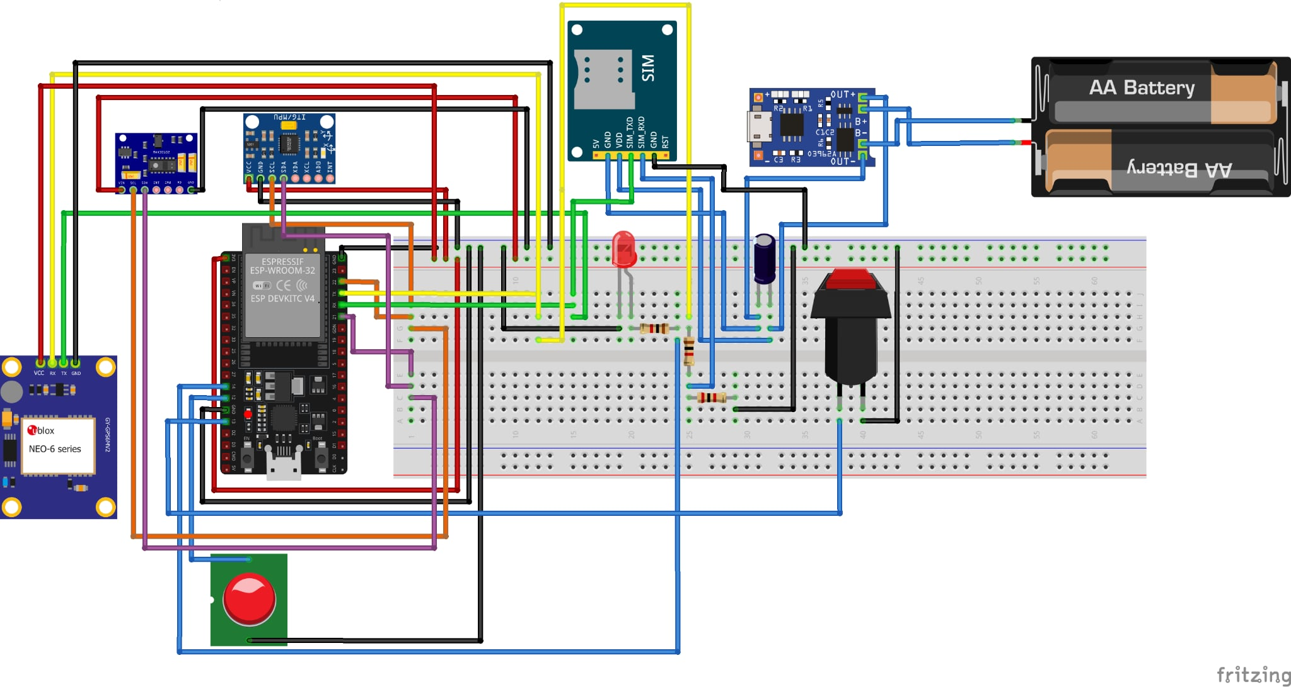

**Receiver:**

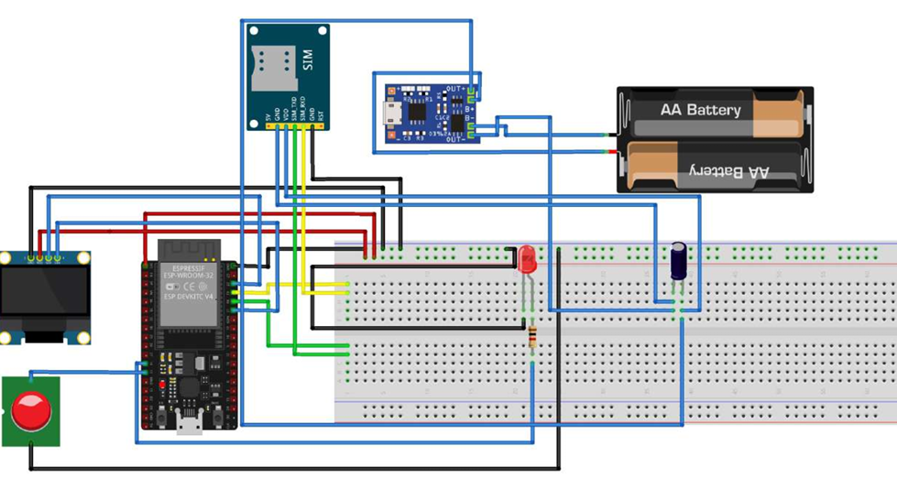

## **Future Implications.**

In the future, this system can be further enhanced with advanced AI-driven injury prediction, integration with military command centers for real-time soldier health monitoring, and encrypted communication for higher security. Additional features like drone-assisted rescue location mapping and medical triage assistance can also be added. Injury detection system also can be added in future.This will make the system highly valuable in both military combat and disaster rescue missions.